

Template – FERPA Release Process
The template named “Template – FERPA Release Process” is applicable to Anthology Student.

Purpose and Outcome
This template provides a form sequence and supporting workflow for a FERPA Release form to be submitted by a student. The sequence requires the following:
- A Student record must exist in the Anthology Student database.
- The student must have a Portal login to log into this authenticated sequence.
- FERPA student information and FERPA groups must be configured in Anthology Student.
Upon completion of the sequence:
- The options selected on the FERPA form are added to the student record in Contact Manager.
- The Data Block Indicator (FERPA) is selected and the FERPA icon is displayed on the student record.

Prerequisites
The template was built in Forms Builder using the applications listed below. The template is forward compatible with later versions of the listed applications.
Application | Compatibility Version
Forms Builder Designer and Renderer | Compatibility Matrix
Web Client for Anthology Student
Workflow Composer
Packages installed from Package Manager in Workflow Composer | Activities and Contracts (V2)  Contracts (V1)  Forms Builder Contracts  Note: Ensure that the Forms Builder Contracts package used in Workflow Composer is aligned with the version used in the Forms Builder. Additionally, confirm that both Activities and Contracts (V1) and Activities and Contracts (V2) packages in Workflow Composer match the versions used in the Student Web Client to avoid compatibility issues.  It depends on which product is being used, for example:  For CRM:  Activities And Contracts (CRM)  Forms Builder Contracts
Workflow Tracking Database | N/A
Staff STS | 3.3.x

Step 1: Download and Import the Template
- Download the template file (xml) to your environment (local drive or network location).
- Log into Forms Builder Designer.
- Click the Export/Import tile.
- Select the Import tab.
- Click Select exported file and navigate to the downloaded template file (xml).
- Click Import.
Note: Import may fail if same files name is already available in environment or overwrite option.
- Export/Import

The following forms will be imported:

FERPA Release Form

Custom - Confirmation Standard No Auto Close

Step 2: In Form Designer…
- From the Forms slide out, select the FERPA Release Form.
- Customize the form for your environment. Modify properties on current fields to make them required, etc., or add/remove fields on form.
Make sure you edit the text in the Labels and HTML controls as applicable for your institution.
Notes:

The form has several HTML components with empty HTML properties. These components serve as placeholders for the form layout.

The Checkbox components are bound to the workflow via the Model property.
The 2 check boxes under the heading “Directory Information to Release” are bound to:
- vm.models.myAckNot
- vm.models.myAckTrue
The 8 check boxes under the heading “Education Information to Release” are bound using an array starting at [0]:
- vm.models.mylist[0] through vm.models.mylist[7]

The array in the Model value assumes that the data in the FERPA tables starts at index value 1 and that there are no gaps between the stored values. You may need to adjust the values to match the FERPA configuration in your CampusNexus Student database.
- Fields and Components
- Save the form.
- Repeat steps 1-3 for the Custom - Confirmation Standard No Auto Close form.

Step 3: In Sequence Designer…
- Select the FERPA Release Form Sequence.
The sequence contains the following forms in this order:

FERPA Release Form

Custom - Confirmation Standard No Auto Close
- Click Save As to create a copy of the sequence/workflow and customize the copy for your use. This way you can always refer to the original sequence/workflow you downloaded.
- Optional - Add a custom style (theme) associated with your campus.
- Themes
- Select your sequence in the Sequences pane.
- In the Properties Pane:
  - Ensure that the Authentication Product is Student.
- Select the End State Form named “Custom - Confirmation Standard No Auto Close”.
- Save the sequence.
- Open the associated sequence workflow.
- Open the Workflow for a Sequence

Step 4: In Workflow Composer…
- Double-click the Submit transition and locate the Save Relationship Addr sequence.
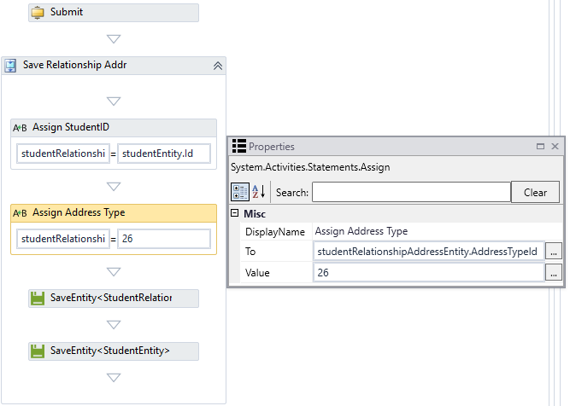
Modify the hard-coded Address Type value of “26” as appropriate. The address type value should be the FERPA Address Type value for your environment. To get the value, you may either query the database directly or use the LookupReferenceItem activity within the workflow.
Simply drop the LookupReferenceItem activity into the workflow and select the following values:
Reference Item Type = Address Type
Reference Item = FERPA Address Type
The activity will return the Id value.
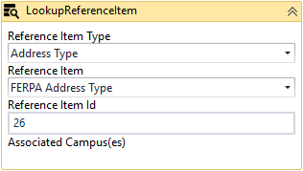

- Scroll down to the Create Directory Info sequence and expand the DoWhile activity.
Ensure that the count value matches the number of items listed in the “Directory Information to Release” section of the form and the number of fields in the cmferpadirfields database table.
In our example there are 16 directory Ids in the table. We are going to loop through and add each one as selected/unselected for the student relationship table.
Note that the count starts at 0. If the list of items in the “Directory Information to Release” section contains 16 items, the Condition of the DoWhile activity needs to be set to “count<15”.
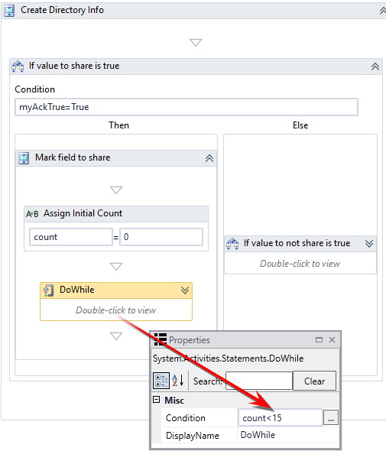
Also ensure that the Assign Id activity within the DoWhile loop matches the actual Id from the cmferpadirfields table.
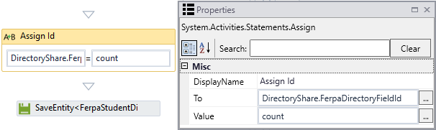
If the Ids are not sequential in the database, add an ExecuteQuery activity to look up the exact Id value.
- ExecuteQuery activity
- Scroll further down to the Academic Info to Share sequence and check the count value in the Condition field of the DoWhile activity.
Ensure that the count value matches the number of items listed in the “Education Information to Release” section of the form and the number of fields in the cmferpaacademicfields table.
In our example, there are 8 directory Id's in the table. We are going to loop through and add each one as selected/unselected based on the selection on the form.
Note that the count starts at 0. If the list of items in the “Education Information to Release” section contains 8 items, the Condition of the DoWhile activity needs to be set to “count<7”.
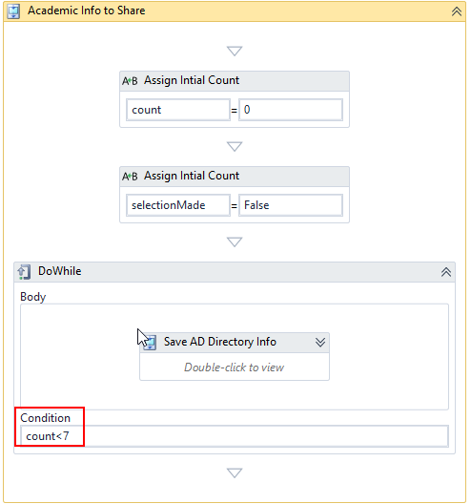
Also ensure that the Assign Id activity within the DoWhile loop matches the actual Id from the cmferpaacademicfields table.
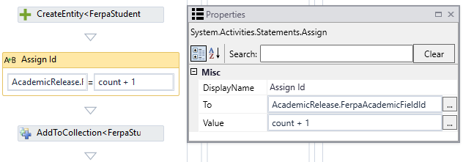
If the Ids are not sequential in the database, add an ExecuteQuery activity to look up the exact Id value.
- ExecuteQuery activity

Step 5: In Forms Renderer and Anthology Student…
Select your sequence and try it out!
- Sequence List
- Find your FERPA Release Form Sequence and copy the URL to the clipboard.
- Log in to Portal as a student and complete the form sequence.
- In Anthology Student:
  - Verify that the options selected on the FERPA form are added to the student record in Contact Manager.
  - Verify the Data Block Indicator (FERPA) is selected and the FERPA icon is displayed on the student record.

Step 6: Lastly…
Once your updated sequence has been tested successfully, it is recommended that you disable the workflow for the original Template version.
- In Workflow Composer, in the Server section of the ribbon, click Open.
- Find the workflow named “FERPA Release Form Sequence”.
- Clear the Enabled check box and click Save.

